Epsom & Ewell F.C.
23
v
Westfield
Tuesday, 24th March 2015
Good evening! For our league match today we welcome the players and officials of Westfield, along with the match officials and of course our own regular supporters.

We were due to meet originally on 31st January but our one home postponement of the season occurred that day. Whilst we have no trouble here at Chipstead with heavy rain, it can get a bit chilly and the snow from the night before just wouldn’t clear.

I wrote back then about it being a surprise that our opponents were so low in the table and whilst it isn’t going to be a season they will look back on with particular fondness, it does at least look as though they are going to survive now. Four points out of six against Camberley Town and a win at Spelthorne on Saturday tells you that they clearly deserve to be playing at this level.

Since Westfield last visited us for the opening home game of season 2013/14 we have had two visits to their recently updated ground. The less said about the actual results on those occasions (0-3,0-4) the better, but the venue itself has changed beyond recognition and is well worth a visit when we go there next season as we surely will.

There is very little to write about today having been here just three days ago for the match against Badshot Lea. As a result we have a smaller programme tonight, although by way of an apology we are giving away a copy of the original programme from January’s postponed match, which might not sound a lot, but bear in mind that some clubs would have just recycled the old issue and you’d be reading about information that was two months out of date instead. If you haven’t got your earlier issue, just ask at the gate as there is still plenty of information in it.

Against Badshot Lea on Saturday, we started slowly but once we got going we were well on top against a side that have been in superb form and Kyle Hough scored another three goals in our 3-0 win. It was our first home hat trick for over six years and I hope we don’t have to wait that long for another one!

On Saturday we travel to Guildford City before congregating here once again in a fortnight’s time for our penultimate home game of the season against Colliers Wood United. Apart from the Easter Monday fixture at Horley and our rearranged trip to Molesey two days after that, we have no other midweek fixtures as this season has been a better one weather-wise than the previous two.

For those who missed it, our Super Six Predictor was claimed on Saturday at £361 by Tony Ferdinando, father of our midfielder Matt. So we start again tonight with a jackpot of £50!

Thanks for watching. Glyn, the boys and the club appreciate your support.

Enjoy the game!

Rich

Cover photo this week by Gemma Jarman

Alex McKay heads us into the lead against Westfield back in August 2013, but who are the other three Salts in the picture?

Cherry Red Records
Combined Counties League
Premier Division Table 2014/15
inc Saturday  21st March 2015 | P | W | D | L | F | A | Pts | GD | H | A
Camberley Town | 34 | 23 | 6 | 5 | 78 | 28 | 75 | +50 | 2-4 | 0-1
Cove | 35 | 22 | 6 | 7 | 82 | 55 | 72 | +27 | 2-2 | 0-1
Molesey | 31 | 23 | 1 | 7 | 84 | 31 | 70 | +53 | 1-3 | 8/4
Ashford Town (Mx) | 33 | 21 | 3 | 9 | 79 | 46 | 69 | +33 | 2-4 | 3-1
Windsor | 34 | 19 | 4 | 11 | 81 | 49 | 61 | +32 | 0-5 | 11/4
Spelthorne Sports | 34 | 17 | 4 | 13 | 66 | 58 | 55 | +8 | 4-3 | 3-0
Badshot Lea | 32 | 15 | 5 | 12 | 63 | 50 | 50 | +13 | 3-0 | 2-4
Hartley Wintney | 34 | 15 | 5 | 14 | 48 | 63 | 50 | -15 | 2-1 | 1-2
Epsom & Ewell | 32 | 14 | 4 | 14 | 60 | 56 | 46 | +4 | - | -
Colliers Wood United | 33 | 13 | 5 | 15 | 58 | 57 | 44 | +1 | 4/4 | 2-3
Farnham Town | 32 | 12 | 6 | 14 | 67 | 74 | 42 | -7 | 2-4 | 2-0
Bedfont Sports | 32 | 12 | 3 | 17 | 46 | 61 | 39 | -7 | 0-1 | 2-0
Raynes Park Vale | 30 | 11 | 6 | 13 | 42 | 50 | 39 | -8 | 0-1 | 2-0
Westfield | 32 | 10 | 8 | 14 | 47 | 55 | 38 | -8 | 24/3 | 0-4
Mole Valley SCR | 33 | 11 | 5 | 17 | 54 | 82 | 38 | -28 | 1-0 | 5-2
Chertsey Town | 33 | 11 | 4 | 18 | 55 | 73 | 37 | -18 | 1-2 | 2-1
Knaphill | 33 | 10 | 5 | 18 | 46 | 70 | 35 | -24 | 18/4 | 4-1
Frimley Green | 34 | 9 | 4 | 21 | 53 | 86 | 31 | -33 | 0-0 | 25/4
Hanworth Villa | 32 | 8 | 6 | 18 | 49 | 66 | 30 | -17 | 1-1 | 5-2
Guildford City | 30 | 9 | 3 | 18 | 55 | 81 | 30 | -26 | 4-1 | 28/3
Horley Town | 31 | 7 | 7 | 17 | 55 | 80 | 28 | -25 | 2-2 | 6/4

Lucky Day? – 24th March
Played 12 - Won 7 Drawn 2 Lost 3 - F 30 A 23 - PPG 1.92 - Very Good
Club record against Westfield
Played 15 - Won 10 Drawn 2 Lost 3 - F 36 A 26 - PPG 2.13 - Very Good
Last visit
Tuesday 6th August 2013 - Won 2-1 - Combined Counties League

First Eleven Appearances - (max 41 inc Badshot Lea)
Name | Debut | 2014/15 |  |  |  | Career Totals
 |  | App | Sub | Total | Goals | App | Sub | Total | Goals
BROWN Oshane* | 30/08/2014 | 2 | 0 | 2 | 0 | 2 | 0 | 2 | 0
BURNS Robbie | 14/08/2007 | 3 | 2 | 5 | 0 | 205 | 16 | 221 | 121
COOPER-SMITH Daryl | 03/01/2015 | 5 | 3 | 8 | 3 | 5 | 3 | 8 | 3
CURRIE Sam | 04/08/2012 | 8 | 4 | 12 | 0 | 102 | 9 | 111 | 2
DEAN Dan | 02/08/2014 | 30 | 1 | 31 | 0 | 30 | 1 | 31 | 0
DEWAR Ali | 29/10/2011 | 5 | 6 | 11 | 3 | 55 | 35 | 90 | 10
DOUGLIN Karl* | 03/08/2013 | 1 | 0 | 1 | 1 | 41 | 3 | 44 | 14
DOWNS Carl* | 17/09/2011 | 4 | 1 | 5 | 0 | 94 | 13 | 107 | 2
EACOTT Michael | 02/08/2014 | 38 | 0 | 38 | 0 | 38 | 0 | 38 | 0
FARRELL Matt | 02/08/2014 | 35 | 3 | 38 | 4 | 35 | 3 | 38 | 4
FERDINANDO Matt | 20/09/2014 | 22 | 4 | 26 | 6 | 22 | 4 | 26 | 6
FRANKLIN Ben | 03/03/2015 | 1 | 0 | 1 | 0 | 1 | 0 | 1 | 0
GAFFNEY Luke* | 16/08/2014 | 10 | 1 | 11 | 0 | 10 | 1 | 11 | 0
HARPER Tommy* | 15/04/2014 | 1 | 0 | 1 | 0 | 2 | 1 | 3 | 0
HAYWARD Ben | 07/03/2007 | 6 | 0 | 6 | 0 | 242 | 28 | 270 | 18
HOADLEY Harry | 27/08/2011 | 6 | 1 | 7 | 0 | 7 | 1 | 8 | 0
HOUGH Kyle | 14/08/2007 | 34 | 3 | 37 | 26 | 288 | 15 | 303 | 163
JARMAN Mark* | 08/08/2009 | 5 | 5 | 10 | 0 | 136 | 51 | 187 | 76
MARVELL Dale* | 15/01/2000 | 11 | 5 | 16 | 5 | 261 | 45 | 306 | 85
MCGREGOR Alex | 08/08/2009 | 13 | 2 | 15 | 1 | 170 | 56 | 226 | 27
MCKAY Alex | 20/12/2008 | 13 | 4 | 17 | 1 | 78 | 26 | 104 | 8
MURPHY George | 28/03/2013 | 22 | 1 | 23 | 1 | 63 | 5 | 68 | 3
MUTIMA Lionel* | 05/08/2014 | 4 | 2 | 6 | 0 | 4 | 2 | 6 | 0
NELMES Elliott* | 05/08/2014 | 2 | 0 | 2 | 0 | 2 | 0 | 2 | 0
PANAYI Anthony | 14/11/2010 | 33 | 1 | 34 | 0 | 160 | 15 | 175 | 4
PANAYIOUTOU Savva | 03/01/2015 | 9 | 2 | 11 | 2 | 9 | 2 | 11 | 2
ROBINSON Matt | 01/12/2012 | 18 | 2 | 20 | 3 | 19 | 5 | 24 | 4
ROBINSON Sam | 22/10/2011 | 24 | 1 | 25 | 7 | 48 | 4 | 52 | 12
ROWE Steve | 27/08/2011 | 14 | 1 | 15 | 0 | 19 | 2 | 21 | 0
SHAW Ollie* | 20/09/2014 | 0 | 10 | 10 | 0 | 0 | 10 | 10 | 0
SMITH Matt | 08/08/2009 | 0 | 1 | 1 | 0 | 91 | 43 | 134 | 10
SMITH Taylor* | 02/08/2014 | 13 | 2 | 15 | 7 | 13 | 2 | 15 | 7
TANTON Matt | 02/08/2014 | 18 | 4 | 22 | 1 | 18 | 4 | 22 | 1
TAYLOR James | 26/08/2013 | 34 | 1 | 35 | 2 | 51 | 7 | 58 | 3
VAN GELDER Julian* | 12/09/2006 | 0 | 1 | 1 | 0 | 0 | 2 | 2 | 0
WHITE Sean* | 02/08/2014 | 6 | 13 | 19 | 3 | 6 | 13 | 19 | 3
YOUNG Conor Jack | 07/03/2015 | 1 | 0 | 1 | 0 | 1 | 0 | 1 | 0
Own Goal |  |  |  |  | 1
* Player has left the club

Results and Fixtures
Combined Counties League Cup QF – Saturday 21st March
Worcester Park | 1-3 | Windsor
Combined Counties League – Saturday 21st March
Epsom & Ewell | 3-0 | Badshot Lea
Farnham Town | 1-1 | Camberley Town
Frimley Green | 1-2 | Guildford City
Hanworth Villa | 3-0 | Ashford Town (Mx)
Hartley Wintney | 2-2 | Molesey
Horley Town | 0-2 | Colliers Wood United
Mole Valley SCR | 0-4 | Knaphill
Raynes Park Vale | 2-1 | Cove
Spelthorne Sports | 1-3 | Westfield
Surrey Senior Cup Semi-Final – Tuesday 24th March
Molesey | V | Met Police
Combined Counties League – Tuesday 24th March
Bedfont Sports | V | Horley Town
Epsom & Ewell | V | Westfield
Knaphill | V | Badshot Lea
Mole Valley SCR | V | Ashford Town (Mx)
Spelthorne Sports | V | Raynes Park Vale
Combined Counties League – Wednesday 25th March
Guildford City | V | Farnham Town
Combined Counties League – Saturday 28th March
Ashford Town (Mx) | V | Frimley Green
Badshot Lea | V | Raynes Park Vale
Bedfont Sports | V | Windsor
Camberley Town | V | Mole Valley SCR
Colliers Wood United | V | Hanworth Villa
Guildford City | V | Epsom & Ewell
Hartley Wintney | V | Chertsey Town
Horley Town | V | Knaphill
Molesey | V | Farnham Town
Combined Counties League Cup SF – Tuesday 31st March
Windsor | V | Camberley Town
Combined Counties League – Tuesday 31st March
Molesey | V | Chertsey Town
Spelthorne Sports | V | Raynes Park Vale
Results and Fixtures
Combined Counties League – Tuesday 31st March
Westfield | V | Horley Town
Combined Counties League Cup SF – Wednesday 1st April
Colliers Wood United | V | Farnham Town
Combined Counties League – Saturday 4th April
Ashford Town (Mx) | V | Knaphill
Chertsey Town | V | Frimley Green
Cove | V | Windsor
Epsom & Ewell | V | Colliers Wood United
Farnham Town | V | Bedfont Sports
Guildford City | V | Camberley Town
Hartley Wintney | V | Westfield
Molesey | V | Hanworth Villa
Raynes Park Vale | V | Horley Town
Spelthorne Sports | V | Mole Valley SCR
Combined Counties League – Easter Monday 6th April - (11.30 k.o.)
Bedfont Sports | V | Ashford Town (Mx)
Camberley Town | V | Badshot Lea
Frimley Green | V | Farnham Town
Hanworth Villa | V | Spelthorne Sports
Horley Town | V | Epsom & Ewell
Knaphill | V | Hartley Wintney
Mole Valley SCR | V | Molesey
Westfield | V | Guildford City
Windsor | V | Chertsey Town

A home hat trick – finally!
Six years and sixty one days after the last one, Kyle Hough registered a hat trick at home for us in our 3-0 win over Badshot Lea on Saturday.

The last player to do this was Dale Marvell way back on 19th January 2009. Since then we have had NINE hat tricks scored for our club, but all have been performed away from home.

Kyle had scored five previously but all had been away from HQ and in fact the last player to have scored hat tricks both home and away was Andy Webster back in 1991/92 when we were still playing at West Street.

If we had lasted until the end of the season without a home hat trick it would have been the longest run in club history, which is even more amazing when you realise that we haven’t been short of goals in recent years! Congratulations Kyle!

From behind the goal
Epsom & Ewell 3-0 Badshot Lea
Combined Counties League - Premier Division - Saturday 21st March 2015

Hough ticks off another achievement as Salts batter Baggies

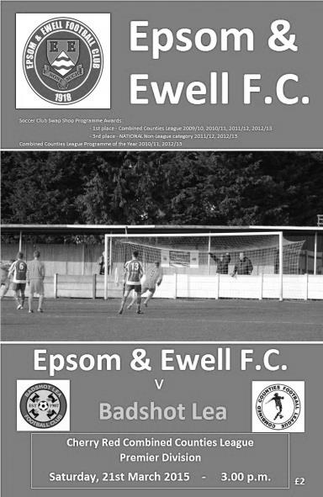
In form Badshot Lea came to High Road fully expecting to clinch their third win in three visits, but our boys were reading a different script and handed them their biggest defeat for months with Kyle Hough scoring his first ever hat trick at home for our club to make it ten goals in his last seven starts.

It is hard to imagine with 160 goals for the club going in to this match that he had never achieved this previously. Nor had Robbie Burns or Mark Jarman, other likely achievers in recent years. In fact you have to go back to January 2009 since we last had a home hat trick from any player when Dale Marvell completed one in the first half against North Greenford United and we were in fact only nine games away from setting a new club record of six and a half years without one.

However, this is only half the story today as the whole team, to a man put in a good shift to extend the unbeaten run to six league matches against a team we had an awful recent record against. In terms of personnel Sam Robinson and Matt Ferdinando came back into the starting eleven at the expense of the absent Daryl Cooper-Smith and the rested Sam Currie, so Dan Dean was given the armband for the day and on a bone dry pitch with a deceptively cold wind we kicked off towards the clubhouse end for a change. We didn't start well though and as early as the fifth minute we were in trouble from a long throw which was unwittingly flicked on by James Taylor straight to the feet of their striker who got away a good shot, but Michael Eacott made a superb low save with his left hand, pushing the ball wide enough so that the follow up could only be fired into the side netting.

We attacked moments later and Hough headed the ball out to Ferdinando who beat his man and cut in from the right with his low shot being well saved by Ashley West the visiting keeper, but as the game swung from end to end we were nearly caught out by another long throw and the next ten minutes was spent largely in trying to clear our lines.

After 19 minutes a deep Dean cross from the left was met at the far post by Ferdinando but he was stretching and couldn't keep his shot down. However, four minutes later he tried to flick the ball on and was knocked to the ground by a clumsy challenge. It was the sort of foul that you normally see given in the middle of the park, but this one happened in the visitors penalty area and almost without an appeal the referee awarded the penalty. Hough then did what Hough normally does and put us in front from the spot with the clock in the 24th minute.

There was a humorous incident on the half hour mark when James Ayres received a yellow card for not retreating from a free kick after Dean had hit the ball at him from close range. Moments later they had a free kick of their own but in trying to kick the ball against Matt Farrell from a yard away, the player missed him entirely and sent the free kick out for a goal kick which didn't please his Manager!

From this point onwards we were on top and finished the half strongly. Robinson sent Hough clean through but he was held up and eventually dispossessed by a closing defender. A few minutes after this Hough put Savva 'Agi' Panayiotou in, but the ball was on his weaker right foot and instead of choosing to shoot he squared the ball to Ferdinando who probably wasn't expecting the ball to come to him, and his first touch pushed him wide with his chipped effort just dropping over the bar. Even Eacott was getting in on the act with a booming goal kick that nearly caught his opposite number out and he had to move smartly to stop the ball while standing back on his own goal line.

Just as the referee was looking at his watch the ball found Hough on the left who drilled his shot low; the ball deflecting up into the roof of the net off West's leg for our second goal and there was time to kick off but no more before the whistle went for the break.

At this stage it could be argued by the visitors that they were unfortunate to be behind by two goals but by the end of the match they could have no complaints as we pretty much ran the show for the second forty five. Robinson was fed by Hough but his snap shot was saved by the well-positioned West as early as the 48th minute. Hough's shot on target was well saved in the 56th minute as Robinson returned the favour with a good pass before Alex McKay headed just over the bar after Dean had headed a Robinson corner back across goal. After 66 minutes we produced one of the best moves of the match when Robinson found Ferdinando on the right and his defence splitting pass put Hough through but West made a great low save to block his close range effort.

West was becoming the busiest player on the pitch as we stretched their overworked defence time and again. Robinson had two attempts, the first struck just wide following another good piece of play and the second shot from the edge of the area, although it lacked its customary power and was easily saved. In the 86th minute West made his best save of the game after Robinson shot at goal from eight yards out but somehow he got a hand to it, despite momentum carrying him in the opposite direction. West's reward however was to pick the ball out of the net as his defenders only cleared the ball to Taylor who played the ball back in for Hough who chased it and reached it just ahead of the advancing keeper, poking it between his legs to secure his hat trick.

We nearly had a fourth goal in injury time when Panayiotou received the ball from a poor keeper clearance and shot goalwards but a defender was on the line to control and hack clear, and the final whistle shortly afterwards confirmed the extension of our unbeaten League run to six matches and our first home clean sheet since October against a team we had beaten just the once in our last eleven attempts and who had only lost once in the League since November. It was a very good day at the office!

Team: Michael Eacott, James Taylor, Steve Rowe, Anthony Panayi, Alex McKay, Savva 'Agi' Panayiotou, Dan Dean (c), Matt Farrell, Kyle Hough, Sam Robinson, Matt Ferdinando

Sub: Sam Currie for Rowe (87)

Centre page for results

Centre page for results

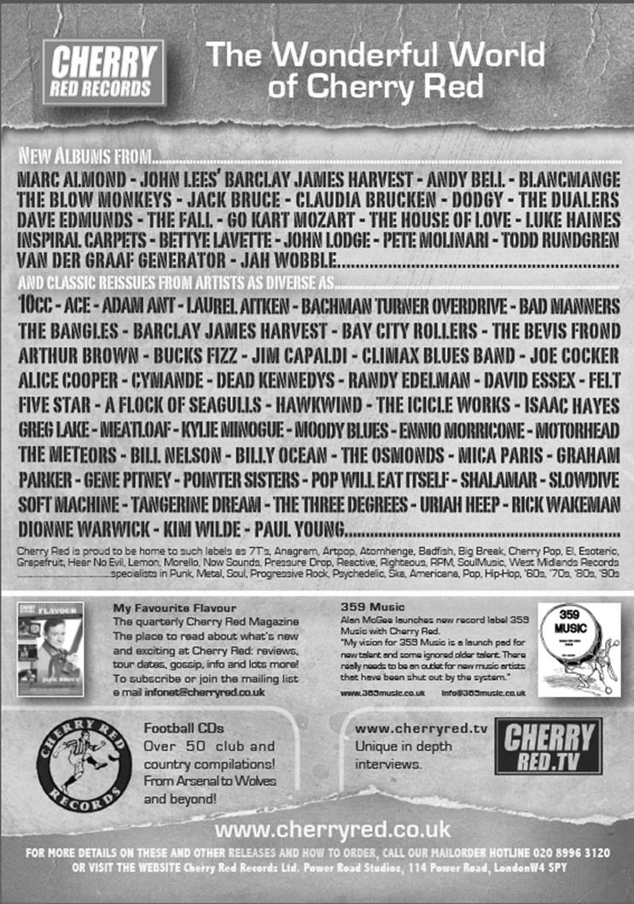

Combined Counties League

Premier Division FORM Table

Last Six Games | W | D | L | F | A | Pts | GD | H | A
Epsom & Ewell | 4 | 2 | 0 | 12 | 5 | 14 | +7 | - | -
Molesey | 4 | 1 | 1 | 13 | 7 | 13 | +6 | 1-3 | 8/4
Raynes Park Vale | 4 | 1 | 1 | 9 | 6 | 13 | +3 | 0-1 | 2-0
Guildford City | 4 | 0 | 2 | 14 | 11 | 12 | +3 | 4-1 | 28/3
Frimley Green | 4 | 0 | 2 | 9 | 7 | 12 | +2 | 0-0 | 25/4
Westfield | 3 | 2 | 1 | 10 | 6 | 11 | +4 | 24/3 | 0-4
Hanworth Villa | 3 | 1 | 2 | 14 | 10 | 10 | +4 | 1-1 | 5-2
Ashford Town (Mx) | 3 | 1 | 2 | 15 | 13 | 10 | +2 | 2-4 | 3-1
Badshot Lea | 3 | 1 | 2 | 7 | 5 | 10 | +2 | 3-0 | 2-4
Colliers Wood United | 2 | 3 | 1 | 10 | 8 | 9 | +2 | 4/4 | 2-3
Camberley Town | 2 | 2 | 2 | 8 | 7 | 8 | +1 | 2-4 | 0-1
Windsor | 2 | 1 | 3 | 14 | 12 | 7 | +2 | 0-5 | 11/4
Cove | 2 | 1 | 3 | 10 | 10 | 7 | 0 | 2-2 | 0-1
Spelthorne Sports | 2 | 1 | 3 | 9 | 11 | 7 | -2 | 4-3 | 3-0
Chertsey Town | 2 | 1 | 3 | 14 | 16 | 7 | -2 | 1-2 | 2-1
Farnham Town | 2 | 1 | 3 | 9 | 11 | 7 | -2 | 2-4 | 2-0
Hartley Wintney | 2 | 1 | 3 | 9 | 14 | 7 | -5 | 2-1 | 1-2
Knaphill | 2 | 0 | 4 | 11 | 10 | 6 | +1 | 18/4 | 4-1
Horley Town | 1 | 2 | 3 | 8 | 14 | 5 | -6 | 2-2 | 6/4
Bedfont Sports | 1 | 0 | 5 | 8 | 13 | 3 | -5 | 0-1 | 2-0
Mole Valley SCR | 0 | 0 | 6 | 3 | 20 | 0 | -17 | 1-0 | 5-2

Cover photo question
On page one I asked which other three Salts were in the picture with Alex McKay.

The answers were Kyle Hough, Nathan Ayling and Reece Jackson. How many did you get?

Club Records - 24th March
Date | Day | Competition |  | Opponents |  | Scorers
24/03/28 | Sat | London League | A | Finchley | 2-2 | J.Parr, R.Marlow
24/03/34 | Sat | London League | H | Tilbury | 6-1 | E.Flight (2), W.Challis, J.Jones, M.Wiggins, R.Marlow
24/03/51 | Sat | Corinthian League | A | Hounslow Town | 1-7 | S.Faggetter
24/03/56 | Sat | Corinthian League | H | Tilbury | 3-0 | J.Sorensen, N.Ambrose, D.Hermitage
24/03/62 | Sat | Corinthian League | H | Wembley | 1-2 | J.Leedham
24/03/67 | Fri | Athenian League 2 | H | Marlow | 0-0
24/03/79 | Sat | Isthmian League 1 | H | Harrow Borough | 4-1 | T.Tuite (2), J.Hunn, G.Archer
24/03/90 | Sat | Isthmian League 2s | H | Eastbourne United | 3-1 | L.Edwards (2), C.Hadingham
24/03/92 | Tue | Isthmian League 3 | H | Hertford Town | 3-1 | A.Webster, M.Laverty, A.Skeet
24/03/98 | Tue | Isthmian League 3 | H | Aveley | 4-2 | A.Boxall, K.Webb, S.Smith, P.Bunter
24/03/07 | Sat | Combined Counties Premier Division | A | Wembley | 0-5
24/03/08 | Mon | Combined Counties Premier Division | A | Banstead Athletic | 3-1 | R.Shoefield, R.Burns, A.Pero
Historical Decades
90 years ago – Epsom Town
28/03/25 | Sat | Friendly | H | Watford Old Boys | 2-4 | W.Challis + one other
80 years ago – Epsom F.C.
23/03/35 | Sat | London League Cup 1 replay | A | P.O.Engineers | 3-1 | H.Pullen (2), T.Dunne
70 years ago – War time Epsom Town
24/03/45 | Sat | Friendly | H | R.A.O.C. Merstham | 1-4 | L.Dowding
60 years ago – Epsom F.C.
26/03/55 | Sat | Surrey Senior Shield SF | H | Camberley Town | 3-1 | B.Musto (2), B.Nuth
50 years ago – Epsom & Ewell
27/03/65 | Sat | Athenian League 1 | H | Uxbridge | 1-3 | R.Wallbanks
40 years ago – Epsom & Ewell
29/03/75 | Sat | F.A. Vase SF2 | A | Stamford | 0-0
30 years ago – Epsom & Ewell
23/03/85 | Sat | Isthmian League Premier Division | H | Wokingham Town | 1-1 | S.Hill
20 years ago – Epsom & Ewell
25/03/95 | Sat | Isthmian League 3 | A | Leighton Town | 1-0 | K.Webb
10 years ago – Epsom & Ewell
26/03/05 | Sat | Isthmian League 2 | A | Camberley Town | 1-2 | R.Ingham
History Corner – 24th March
There is really only one thing to cover this week and that is to remind those who weren’t there that 40 years ago this week we qualified for the Final of the F.A. Vase by securing a 0-0 draw at Stamford to win the two-legged tie 2-1 on aggregate.

It had been a nervy enough experience seven days previously when on 22nd March 1975 we hosted and defeated the United Counties League side 2-1 at West Street after trailing at the half, so what would the return leg be like?

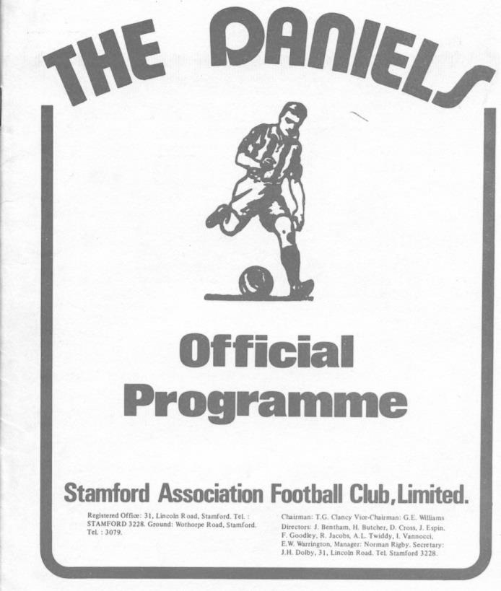
Being only eight years old and completely unaware of the existence of the football club less than five miles from where I lived at the time (Worcester Park) I obviously wasn’t at either game, but having spoken to many that were, it was clear that it was a day they wouldn’t ever forget.

The club ran coaches to the match and 500 supporters took up the offer. They made up a substantial amount of the 2,500 attendance at the recently demised Wothorpe Road.

With the Stamford players reportedly on a “huge” bonus of £35 a man if they won through to the Final they were clearly determined to break us down but our Manager Pat O’Connell and his boys were equally resolute and well-prepared to defend our hard-earned advantage.

There were inevitably some scares along the way, including one where the home side struck the ball into our side netting and some of our people thought at first that it had gone in, and when the final whistle blew the feeling was probably more one of relief than celebration. We were going to Wembley Stadium! Bring on Hoddesdon Town!

Westfield F.C. – History
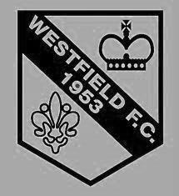
The Club was formed in 1953 as Westfield Boys Club playing in the Woking and District League and also running a youth team. From the start the Club had success in the competitions entered. Among the trophy’s won in the early years were the Surrey Youth Invitation Cup in 1953/54, the Surrey Junior Charity Cup in 1954/55 and 1955/56, the Surrey Junior Cup at the first attempt in 1955/56 and the Surrey Youth Cup in 1956/57.

Following several seasons in local league football the Club made the break into Surrey Intermediate Football using the present ground at Woking Park, Kingfield. Successes soon came and, after becoming League Champions and League Cup winners on several occasions in the subsequent seasons, the Club decided to apply for senior status.

The application was accepted in 1964 and after one season in the Parthenon League, Westfield met the necessary ground grading requirements and joined the Surrey Senior League.

Westfield’s future success in senior football sprang from their ability to attract the best local youngsters and they were successful in winning the Surrey Youth Cup again in 1966/67 and 1969/70 and the Surrey Youth Shield in 1969/70 and 1970/71. This talent matured and there followed three tremendous seasons for the senior side when they won the Surrey Senior League Cup in 1971/72, followed by the League and Cup double in 1972/73 and the League Championship again in 1973/74.

The Surrey Senior League was disbanded and reformed as the Combined Counties Football League in 1978 and Westfield became founder members and retained membership to date. Success, however, has been more difficult to achieve and in recent times the closest the senior team has come to honours was in 1989/90 when they lost the final of the Combined Counties League Cup to Hartley Wintney in extra time.

Season 2000/01 saw the Club enter the Carlsberg FA Vase for the first time, performing beyond expectations before losing in the Fourth Round to Ryman League Arlesey Town, on the way beating Wantage Town, Lewes and Bowers United.

Westfield continued to compete at youth level and they won the Combined Counties Youth League Cup in 1991/92 as well as being runners-up in the League.

Following the installation of floodlights in 1998 the U18 team joined the Southern Youth Floodlight League as members of the Western Division. The Club also run an U16 team playing in the West Surrey Youth League.

Combined Counties League - Premier Division
Tuesday, 24th March 2015 - Kick-off 7.45 p.m.
Epsom and Ewell  (Royal Blue & White hoops) | V |  | Westfield  (Yellow and Black)
 | NUMBERS
Michael Eacott |  |  | Stuart Norman
James Taylor |  |  | Robert Parrott
Steve Rowe |  |  | Danny Sherbourne
Anthony Panayi |  |  | Phil Moore
Alex McKay |  |  | Matt Steer
Matt Farrell |  |  | Luke Beale
© Sam Currie |  |  | Shane Cheeseman
Dan Dean |  |  | Adam Beale
Kyle Hough |  |  | Michael Milne
Sam Robinson |  |  | James Mariner
Savva ‘Agi’ Panayiotou |  |  | Dale Burnham
Daryl Cooper-Smith |  |  | Matt Jackson
Matt Ferdinando |  |  | James Mepham
Matt Robinson |  |  | Jack Hollins
Ben Franklin |  |  | John Brawley
Alex McGregor |  |  | Matt Cronin
George Murphy
Ali Dewar
Conor Jack Young
Glyn Mandeville | MANAGER |  | Dan Snare
Matt Smith | ASSISTANT |  | Dave Powell
Steve Eacott / Alex McKay | COACHES |  | Mike Brawley
Ken Jones | PHYSIO |  | John Steerwood
REFEREE: S.Stoyanov (Bedfont)
ASSISTANTS: S.Earl (Mitcham), R.van Niekerk (Sutton)

OUR NEXT VISITORS TO HIGH ROAD

Colliers Wood United

Saturday 4th April 2015 - Kick-off 3.00 p.m.
Combined Counties League – Premier Division

